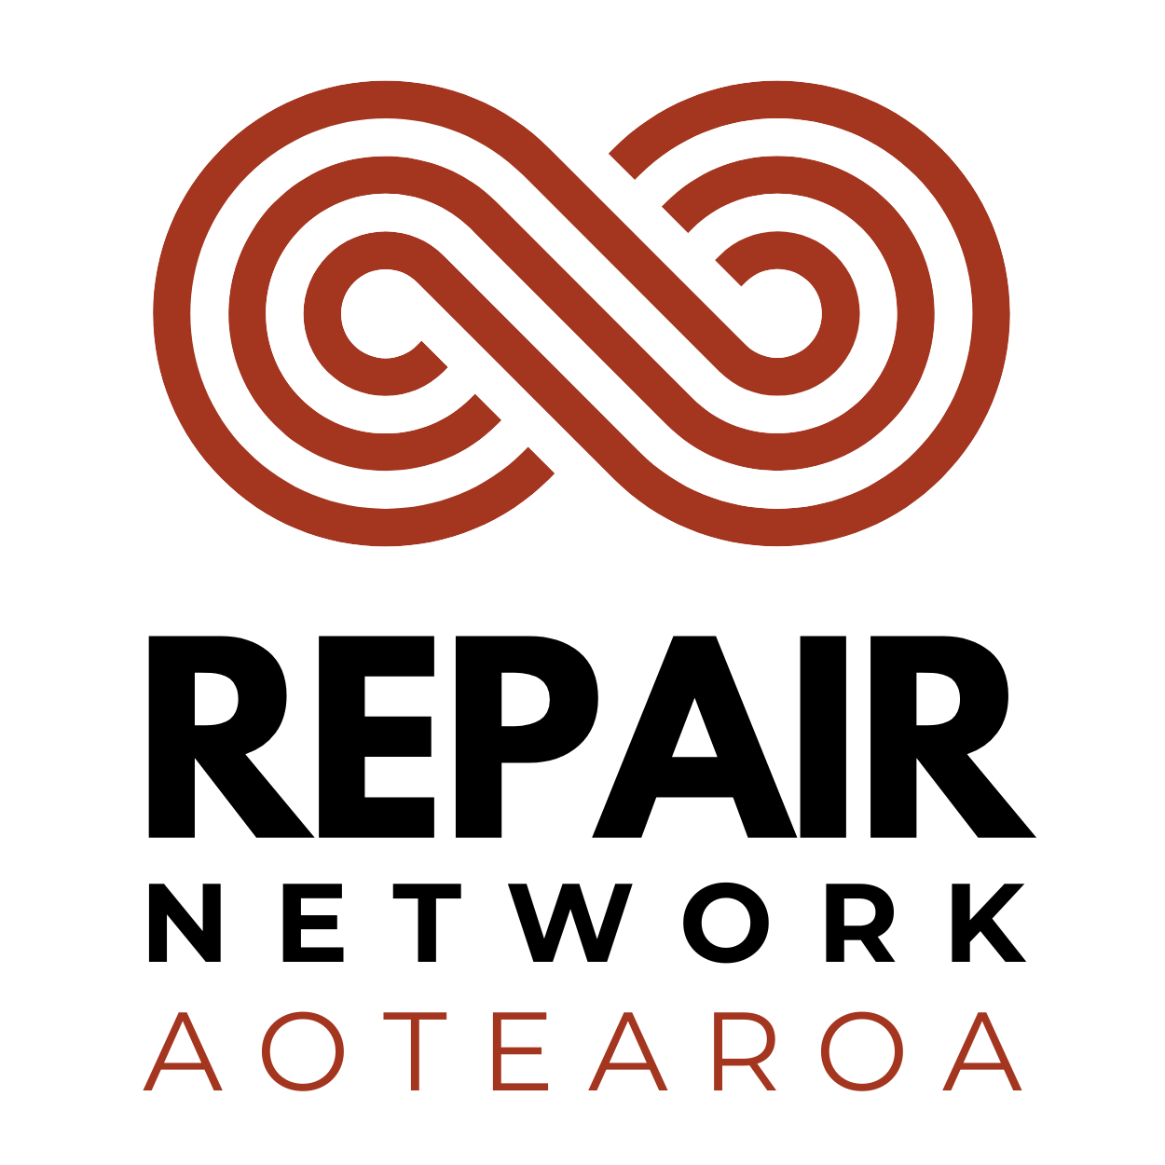

Digital Content Specialist (Contract)
Location: Remote anywhere in New Zealand (optional access to our Central Auckland office)
Contract: Fixed term, ending November 2026
Hours: 8 -10 hours per week (maximum)
Pay: $40–$60 per hour, depending on experience

Help us inspire Aotearoa to repair, reuse and rethink waste.
Repair Network Aotearoa is looking for a creative and proactive Digital Content Specialist to lead the promotion of Repair Festival 2026 (September 5 - 27)—our annual nationwide celebration of repair, reuse and hapori (community) action.
This is a hands-on contract role for someone who loves creating engaging content, building online communities, and delivering digital campaigns that inspire people to take action. You'll work closely with our small, passionate tīma (team) to grow awareness of the Repair Festival, strengthen our online presence, and engage repair groups, volunteers, partners and supporters across Aotearoa.
Working remotely from anywhere in New Zealand, you'll have the flexibility to work from home, with the option to use our Central Auckland office if preferred.

What you'll be doing
- Creating engaging content for Facebook, Instagram and LinkedIn
- Designing graphics and digital assets using Canva
- Writing compelling, audience-focused copy for social media and digital campaigns
- Planning, scheduling and publishing content across our social media platforms
- Building engagement by interacting with followers and responding to comments and messages
- Working with repair groups, partners and stakeholders to amplify campaign messages and share stories
- Monitoring content performance and using data insights to continually improve results
- Applying your understanding of the Meta algorithm and social media best practice to maximise reach and engagement
- Helping grow awareness of Repair Festival 2026 by sharing stories that connect people with our kaupapa and the Right to Repair movement.

About you
You're a confident digital communicator who enjoys creating content that connects with people. You're organised, proactive and comfortable working independently, while collaborating with a passionate team working towards a more sustainable future. An understanding of the principles of Te Tiriti o Waitangi, an appreciation of te ao Māori, and a willingness to support Repair Network Aotearoa's commitment to Te Tiriti in practice would be an advantage.

Essential requirements
- At least 2 years' experience in digital marketing, communications, content creation or a similar role
- Demonstrated experience managing Facebook, Instagram and LinkedIn. Including analysing social media performance data and producing meaningful reports with clear insights and recommendations.
- Demonstrated experience using Meta Insights (and/or Meta Business Suite) to measure campaign performance and identify trends.
- A self-starter who can hit the ground running, work independently, and manage priorities with minimal supervision
- Strong content creation and copywriting skills, with the ability to write engaging, informative and persuasive content
- Experience designing graphics and social media assets (Canva)
- A solid understanding of the Meta algorithm, audience engagement and social media best practice
- Experience building online communities and engaging with followers
- Must be legally entitled to work in New Zealand
- Must provide at least three professional references

Why join us?
Repair Network Aotearoa is a registered charity working to make repair more accessible and celebrated across Aotearoa. This is an opportunity to use your digital skills to support the Right to Repair movement, helping build more resilient hapori (communities) and reduce waste, while enjoying the flexibility of remote work and being part of a passionate, supportive team.
If you're passionate about sustainability, love creating content that sparks conversations and inspires action, we'd love to hear from you.

