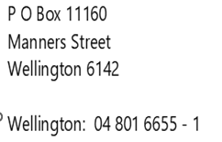 |  | 

JOB DESCRIPTION

Thank you for your interest in the advertised position with Wellington HELP.

The Job Description for the role has not been signed-off, and therefore not available. Your contact details have been noted, and you can expect to receive the JD in due course.

In the meantime, if you have any further queries, please feel free to contact Stephanie Croft.

Ngā mihi

